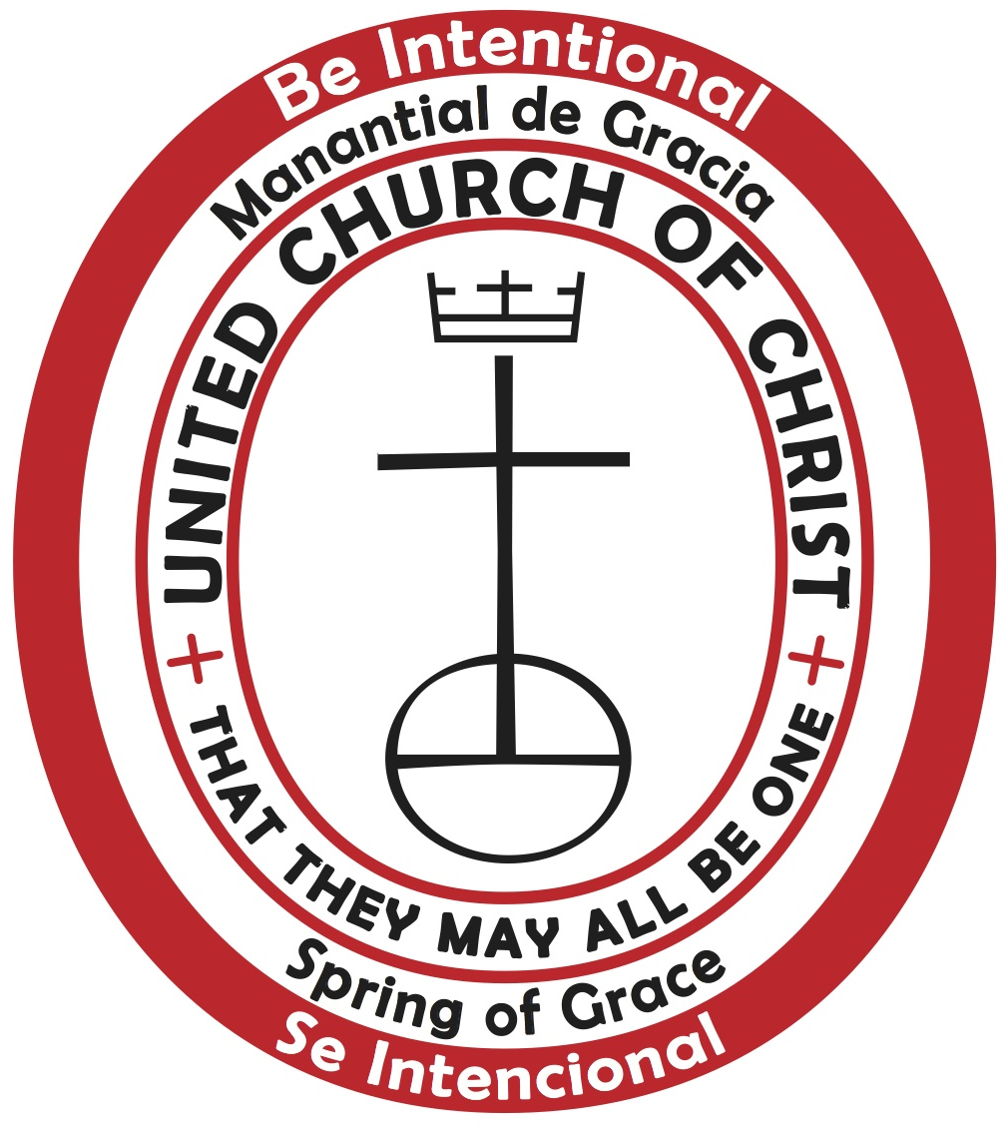 | MANANTIAL DE GRACIA “Spring of Grace”  12 South Main Street, The Chapel, West Hartford, CT  www.mdegucc.wordpress.com mdeg_pastor@yahoo.com (860) 233-3109  Nos reunimos a las 11am, en La Capilla de First Church of Christ Congregational  We Meet: Sundays at 11AM at The Chapel of First Church of Christ Congregational
 |  | 1st Candle – December 3, 2017  David & Maritza Gonzalez  Where are you, God? - Waiting, Expectation  Donde estas, Dios?  Scripture focus: Isaiah 64: 1-9
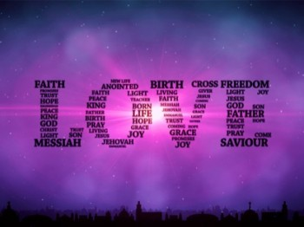 |  | 2nd Candle – December 10, 2017  HOPE / ESPERANZA  Javier & Ana Santiago  Hope...fill with love or love fill with Hope!  Esperanza…lleno de amor o amor lleno de esperanza?  Scripture Focus: Isaiah 40: 1-11
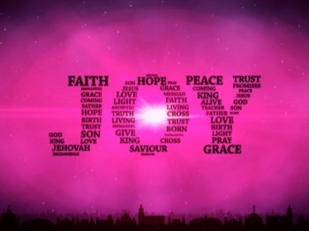 |  | 3rd Candle – December 17, 2017  JOY/ JUBILO  Victor & Jedxenia Santiago  Isn’t Dance part of our Joy?  No es la danza parte de nuestro Gozo?  Scripture Focus: John 1: 6-8, 19-28
 |  | 4th Candle - December 24, 2017  PROMISE / PROMESA  Elivette Mendez Angulo  Isn’t Peace God’s promise to creation?  No es la Paz la promesa de Dios para su creación?  Scripture Focus: Luke 1: 46b-55

